<https://docs.aws.amazon.com/vpc/latest/userguide/vpc-example-private-subnets-nat.html>

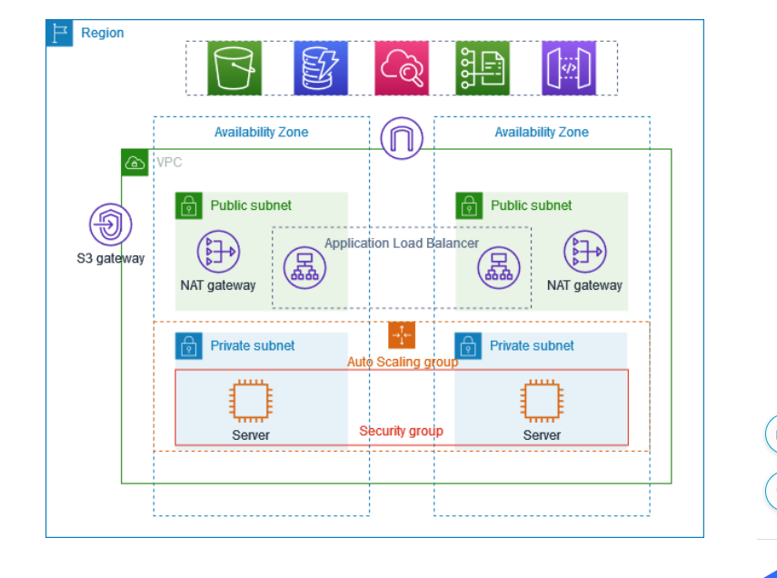

Steps :

Create a VPC with a public and private subnets in different AZ (Use automatic VPC creation option)

Create Autoscaling groups

Create Application load balancer

Not using S3 for this demonstration.

Create a Bastion server (This is a server which acts as an interface between the applications running in private instances within a private subnet and the application load balancer/ outside communication)

Create a VPC:

Create Autoscaling Groups:

First launch the template of the instances need to be implemented:

8000 is the port where applications are running .

Select vpc and the private subnets where the instances need to be implemented and scaled.

Keep autoscaling policies none as of now.

After deploying autoscaling instances are created automatically using the launch template. They don’t have public ip since they are configured to create in private subnet.

Create a bastion server with which you can login to the instances and deploy an application. Create the bastion in the same vpc else it wont be able to access the private subnet instances.

And the security group inbound should be open on port 22 to ssh into the private instances.

Use winscp and copy the .pem key file of the private instances downloaded to your laptop to the bastion service.

Ssh to the private instances and deploy a sample application:

ubuntu@ip-10-0-28-149:~$ ssh -i ubuntukey.pem [ubuntu@10.0.130.200](mailto:ubuntu@10.0.130.200)



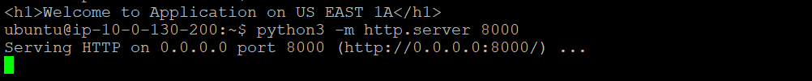

You can install apache2 and run as well a sample html application.

Sudo su -

Apt update

Apt install apache2 -y

Cd /var/www/html

root@ip-10-0-146-39:~# echo "<h1>Welcome to applcation in US EAST 1B AZ</h1>" > /var/www/html/index.html

root@ip-10-0-146-39:~# cat /var/www/html/index.html

<h1>Welcome to applcation in US EAST 1B AZ</h1>

Once deployed , then create application load balancer.

Application load balancer should be in public subnet:

Now use the dns of load balancer and browse. Traffic should be balanced automatically.



---------------------------------------Completed -----------------------------------------------